LAB MST

Que 1:
CREATE TABLE department1 (
dept_id INT PRIMARY KEY,
dept_name VARCHAR(30)
);

CREATE TABLE employee_4 (
emp_id INT PRIMARY KEY,
emp_name VARCHAR(50),
salary NUMERIC(10,2),
dept_id INT REFERENCES department1(dept_id)
);

INSERT INTO department1 VALUES
(1, 'IT'),
(2, 'Sales'),
(3, 'HR');

INSERT INTO employee_4 VALUES
(101, 'Aman', 90000, 1),
(102, 'Neha', 70000, 1),
(103, 'Raj', 50000, 1),
(104, 'Priya', 80000, 2),
(105, 'Karan', 60000, 2),
(106, 'Riya', 40000, 2),
(107, 'Mohit', 75000, 3),
(108, 'Simran', 55000, 3);

SELECT d.dept_name, e.emp_name, e.salary
from employee_4 as e
join department1 as d
on e.dept_id=d.dept_id

where e.salary>(
select avg(salary)
from employee_4
where dept_id=e.dept_id
)
and e.dept_id in(
select dept_id
from employee_4
group by dept_id
having count(*)>=3
)

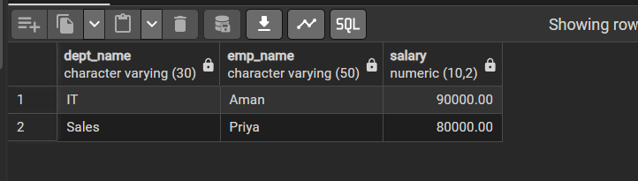

Que 2:
CREATE TABLE bank_customer (
customer_id INT PRIMARY KEY,
customer_name VARCHAR(50),
balance NUMERIC(10,2)
);

CREATE TABLE customer_audit (
audit_id SERIAL PRIMARY KEY,
customer_id INT,
customer_name VARCHAR(50),
action VARCHAR(20),
action_time TIMESTAMP
);

INSERT INTO bank_customer VALUES
(1, 'Rahul', 50000),
(2, 'Neha', 75000);

CREATE OR REPLACE FUNCTION audit_customer
RETURN TRIGGER AS
$$
BEGIN
INSERT INTO customer_audit
(customer_id, customer_name, action, action_time)
values(
new.customer_id, new.customer_name, 'added', current_timestamp
);

return new;
end;

$$

CREATE OR REPLACE FUNCTION delete_audit()
RETURN TRIGGER AS
$$
BEGIN
INSERT INTO customer_audit
(customer_id, customer_name, action, action_time)
values(
old.customer_id, old.customer_name, 'removed', current_timestamp
);

return old;
end;

$$

